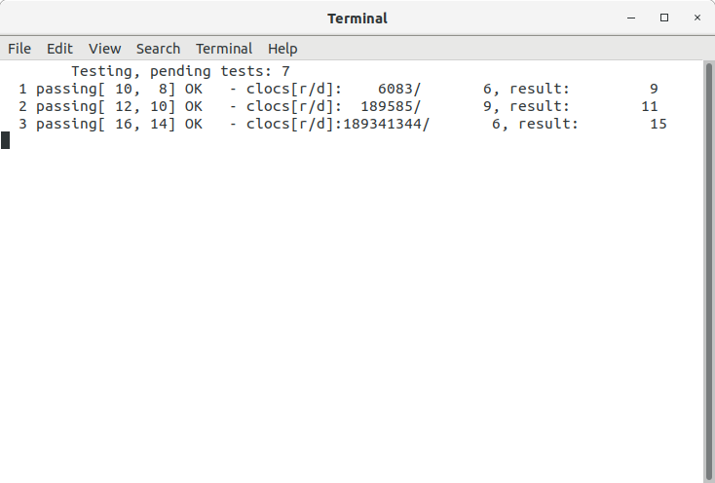

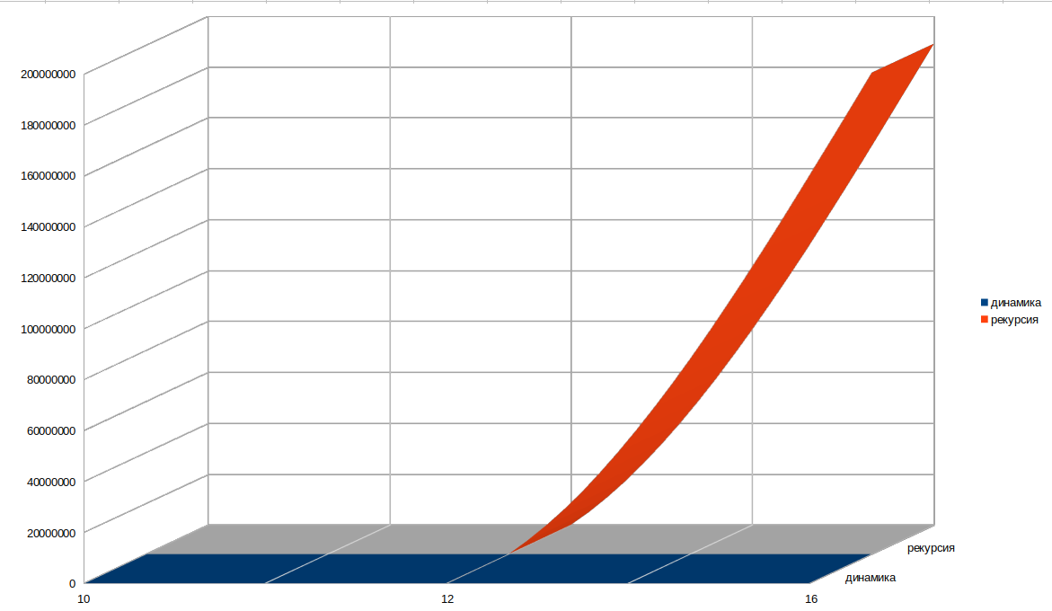
Слово 1 | Слово 2
Вол | Колун

, k -> 1
, -> 0
v, -> 1
, k -> 1
v, k -> 1
, ko -> 2
v, ko -> 2
, -> 0
v, -> 1
, k -> 1
v, k -> 1
v, -> 1
vo, -> 2
, -> 0
v, -> 1
, k -> 1
v, k -> 1
vo, k -> 2
, k -> 1
, -> 0
v, -> 1
, k -> 1
v, k -> 1
, ko -> 2
v, ko -> 2
vo, ko -> 1
, ko -> 2
, k -> 1
, -> 0
v, -> 1
, k -> 1
v, k -> 1
, ko -> 2
v, ko -> 2
, kol -> 3
v, kol -> 3
vo, kol -> 2
, -> 0
v, -> 1
, k -> 1
v, k -> 1
v, -> 1
vo, -> 2
, -> 0
v, -> 1
, k -> 1
v, k -> 1
vo, k -> 2
, k -> 1
, -> 0
v, -> 1
, k -> 1
v, k -> 1
, ko -> 2
v, ko -> 2
vo, ko -> 1
v, -> 1
vo, -> 2
, -> 0
v, -> 1
, k -> 1
v, k -> 1
vo, k -> 2
vo, -> 2
vol, -> 3
v, -> 1
vo, -> 2
, -> 0
v, -> 1
, k -> 1
v, k -> 1
vo, k -> 2
vol, k -> 3
, -> 0
v, -> 1
, k -> 1
v, k -> 1
v, -> 1
vo, -> 2
, -> 0
v, -> 1
, k -> 1
v, k -> 1
vo, k -> 2
, k -> 1
, -> 0
v, -> 1
, k -> 1
v, k -> 1
, ko -> 2
v, ko -> 2
vo, ko -> 1
vol, ko -> 2
, k -> 1
, -> 0
v, -> 1
, k -> 1
v, k -> 1
, ko -> 2
v, ko -> 2
, -> 0
v, -> 1
, k -> 1
v, k -> 1
v, -> 1
vo, -> 2
, -> 0
v, -> 1
, k -> 1
v, k -> 1
vo, k -> 2
, k -> 1
, -> 0
v, -> 1
, k -> 1
v, k -> 1
, ko -> 2
v, ko -> 2
vo, ko -> 1
, ko -> 2
, k -> 1
, -> 0
v, -> 1
, k -> 1
v, k -> 1
, ko -> 2
v, ko -> 2
, kol -> 3
v, kol -> 3
vo, kol -> 2
vol, kol -> 1
, ko -> 2
, k -> 1
, -> 0
v, -> 1
, k -> 1
v, k -> 1
, ko -> 2
v, ko -> 2
, kol -> 3
v, kol -> 3
, k -> 1
, -> 0
v, -> 1
, k -> 1
v, k -> 1
, ko -> 2
v, ko -> 2
, -> 0
v, -> 1
, k -> 1
v, k -> 1
v, -> 1
vo, -> 2
, -> 0
v, -> 1
, k -> 1
v, k -> 1
vo, k -> 2
, k -> 1
, -> 0
v, -> 1
, k -> 1
v, k -> 1
, ko -> 2
v, ko -> 2
vo, ko -> 1
, ko -> 2
, k -> 1
, -> 0
v, -> 1
, k -> 1
v, k -> 1
, ko -> 2
v, ko -> 2
, kol -> 3
v, kol -> 3
vo, kol -> 2
, kol -> 3
, ko -> 2
, k -> 1
, -> 0
v, -> 1
, k -> 1
v, k -> 1
, ko -> 2
v, ko -> 2
, kol -> 3
v, kol -> 3
, kolu -> 4
v, kolu -> 4
vo, kolu -> 3
vol, kolu -> 2
, -> 0
v, -> 1
, k -> 1
v, k -> 1
v, -> 1
vo, -> 2
, -> 0
v, -> 1
, k -> 1
v, k -> 1
vo, k -> 2
, k -> 1
, -> 0
v, -> 1
, k -> 1
v, k -> 1
, ko -> 2
v, ko -> 2
vo, ko -> 1
v, -> 1
vo, -> 2
, -> 0
v, -> 1
, k -> 1
v, k -> 1
vo, k -> 2
vo, -> 2
vol, -> 3
v, -> 1
vo, -> 2
, -> 0
v, -> 1
, k -> 1
v, k -> 1
vo, k -> 2
vol, k -> 3
, -> 0
v, -> 1
, k -> 1
v, k -> 1
v, -> 1
vo, -> 2
, -> 0
v, -> 1
, k -> 1
v, k -> 1
vo, k -> 2
, k -> 1
, -> 0
v, -> 1
, k -> 1
v, k -> 1
, ko -> 2
v, ko -> 2
vo, ko -> 1
vol, ko -> 2
, k -> 1
, -> 0
v, -> 1
, k -> 1
v, k -> 1
, ko -> 2
v, ko -> 2
, -> 0
v, -> 1
, k -> 1
v, k -> 1
v, -> 1
vo, -> 2
, -> 0
v, -> 1
, k -> 1
v, k -> 1
vo, k -> 2
, k -> 1
, -> 0
v, -> 1
, k -> 1
v, k -> 1
, ko -> 2
v, ko -> 2
vo, ko -> 1
, ko -> 2
, k -> 1
, -> 0
v, -> 1
, k -> 1
v, k -> 1
, ko -> 2
v, ko -> 2
, kol -> 3
v, kol -> 3
vo, kol -> 2
vol, kol -> 1
v, -> 1
vo, -> 2
, -> 0
v, -> 1
, k -> 1
v, k -> 1
vo, k -> 2
vo, -> 2
vol, -> 3
v, -> 1
vo, -> 2
, -> 0
v, -> 1
, k -> 1
v, k -> 1
vo, k -> 2
vol, k -> 3
, -> 0
v, -> 1
, k -> 1
v, k -> 1
v, -> 1
vo, -> 2
, -> 0
v, -> 1
, k -> 1
v, k -> 1
vo, k -> 2
, k -> 1
, -> 0
v, -> 1
, k -> 1
v, k -> 1
, ko -> 2
v, ko -> 2
vo, ko -> 1
vol, ko -> 2
vo, -> 2
vol, -> 3
v, -> 1
vo, -> 2
, -> 0
v, -> 1
, k -> 1
v, k -> 1
vo, k -> 2
vol, k -> 3
vol, -> 3
vol, -> 4
vo, -> 2
vol, -> 3
v, -> 1
vo, -> 2
, -> 0
v, -> 1
, k -> 1
v, k -> 1
vo, k -> 2
vol, k -> 3
vol, k -> 4
v, -> 1
vo, -> 2
, -> 0
v, -> 1
, k -> 1
v, k -> 1
vo, k -> 2
vo, -> 2
vol, -> 3
v, -> 1
vo, -> 2
, -> 0
v, -> 1
, k -> 1
v, k -> 1
vo, k -> 2
vol, k -> 3
, -> 0
v, -> 1
, k -> 1
v, k -> 1
v, -> 1
vo, -> 2
, -> 0
v, -> 1
, k -> 1
v, k -> 1
vo, k -> 2
, k -> 1
, -> 0
v, -> 1
, k -> 1
v, k -> 1
, ko -> 2
v, ko -> 2
vo, ko -> 1
vol, ko -> 2
vol, ko -> 3
, -> 0
v, -> 1
, k -> 1
v, k -> 1
v, -> 1
vo, -> 2
, -> 0
v, -> 1
, k -> 1
v, k -> 1
vo, k -> 2
, k -> 1
, -> 0
v, -> 1
, k -> 1
v, k -> 1
, ko -> 2
v, ko -> 2
vo, ko -> 1
v, -> 1
vo, -> 2
, -> 0
v, -> 1
, k -> 1
v, k -> 1
vo, k -> 2
vo, -> 2
vol, -> 3
v, -> 1
vo, -> 2
, -> 0
v, -> 1
, k -> 1
v, k -> 1
vo, k -> 2
vol, k -> 3
, -> 0
v, -> 1
, k -> 1
v, k -> 1
v, -> 1
vo, -> 2
, -> 0
v, -> 1
, k -> 1
v, k -> 1
vo, k -> 2
, k -> 1
, -> 0
v, -> 1
, k -> 1
v, k -> 1
, ko -> 2
v, ko -> 2
vo, ko -> 1
vol, ko -> 2
, k -> 1
, -> 0
v, -> 1
, k -> 1
v, k -> 1
, ko -> 2
v, ko -> 2
, -> 0
v, -> 1
, k -> 1
v, k -> 1
v, -> 1
vo, -> 2
, -> 0
v, -> 1
, k -> 1
v, k -> 1
vo, k -> 2
, k -> 1
, -> 0
v, -> 1
, k -> 1
v, k -> 1
, ko -> 2
v, ko -> 2
vo, ko -> 1
, ko -> 2
, k -> 1
, -> 0
v, -> 1
, k -> 1
v, k -> 1
, ko -> 2
v, ko -> 2
, kol -> 3
v, kol -> 3
vo, kol -> 2
vol, kol -> 1
vol, kol -> 2
, k -> 1
, -> 0
v, -> 1
, k -> 1
v, k -> 1
, ko -> 2
v, ko -> 2
, -> 0
v, -> 1
, k -> 1
v, k -> 1
v, -> 1
vo, -> 2
, -> 0
v, -> 1
, k -> 1
v, k -> 1
vo, k -> 2
, k -> 1
, -> 0
v, -> 1
, k -> 1
v, k -> 1
, ko -> 2
v, ko -> 2
vo, ko -> 1
, ko -> 2
, k -> 1
, -> 0
v, -> 1
, k -> 1
v, k -> 1
, ko -> 2
v, ko -> 2
, kol -> 3
v, kol -> 3
vo, kol -> 2
, -> 0
v, -> 1
, k -> 1
v, k -> 1
v, -> 1
vo, -> 2
, -> 0
v, -> 1
, k -> 1
v, k -> 1
vo, k -> 2
, k -> 1
, -> 0
v, -> 1
, k -> 1
v, k -> 1
, ko -> 2
v, ko -> 2
vo, ko -> 1
v, -> 1
vo, -> 2
, -> 0
v, -> 1
, k -> 1
v, k -> 1
vo, k -> 2
vo, -> 2
vol, -> 3
v, -> 1
vo, -> 2
, -> 0
v, -> 1
, k -> 1
v, k -> 1
vo, k -> 2
vol, k -> 3
, -> 0
v, -> 1
, k -> 1
v, k -> 1
v, -> 1
vo, -> 2
, -> 0
v, -> 1
, k -> 1
v, k -> 1
vo, k -> 2
, k -> 1
, -> 0
v, -> 1
, k -> 1
v, k -> 1
, ko -> 2
v, ko -> 2
vo, ko -> 1
vol, ko -> 2
, k -> 1
, -> 0
v, -> 1
, k -> 1
v, k -> 1
, ko -> 2
v, ko -> 2
, -> 0
v, -> 1
, k -> 1
v, k -> 1
v, -> 1
vo, -> 2
, -> 0
v, -> 1
, k -> 1
v, k -> 1
vo, k -> 2
, k -> 1
, -> 0
v, -> 1
, k -> 1
v, k -> 1
, ko -> 2
v, ko -> 2
vo, ko -> 1
, ko -> 2
, k -> 1
, -> 0
v, -> 1
, k -> 1
v, k -> 1
, ko -> 2
v, ko -> 2
, kol -> 3
v, kol -> 3
vo, kol -> 2
vol, kol -> 1
, ko -> 2
, k -> 1
, -> 0
v, -> 1
, k -> 1
v, k -> 1
, ko -> 2
v, ko -> 2
, kol -> 3
v, kol -> 3
, k -> 1
, -> 0
v, -> 1
, k -> 1
v, k -> 1
, ko -> 2
v, ko -> 2
, -> 0
v, -> 1
, k -> 1
v, k -> 1
v, -> 1
vo, -> 2
, -> 0
v, -> 1
, k -> 1
v, k -> 1
vo, k -> 2
, k -> 1
, -> 0
v, -> 1
, k -> 1
v, k -> 1
, ko -> 2
v, ko -> 2
vo, ko -> 1
, ko -> 2
, k -> 1
, -> 0
v, -> 1
, k -> 1
v, k -> 1
, ko -> 2
v, ko -> 2
, kol -> 3
v, kol -> 3
vo, kol -> 2
, kol -> 3
, ko -> 2
, k -> 1
, -> 0
v, -> 1
, k -> 1
v, k -> 1
, ko -> 2
v, ko -> 2
, kol -> 3
v, kol -> 3
, kolu -> 4
v, kolu -> 4
vo, kolu -> 3
vol, kolu -> 2
vol, kolu -> 2
, ko -> 2
, k -> 1
, -> 0
v, -> 1
, k -> 1
v, k -> 1
, ko -> 2
v, ko -> 2
, kol -> 3
v, kol -> 3
, k -> 1
, -> 0
v, -> 1
, k -> 1
v, k -> 1
, ko -> 2
v, ko -> 2
, -> 0
v, -> 1
, k -> 1
v, k -> 1
v, -> 1
vo, -> 2
, -> 0
v, -> 1
, k -> 1
v, k -> 1
vo, k -> 2
, k -> 1
, -> 0
v, -> 1
, k -> 1
v, k -> 1
, ko -> 2
v, ko -> 2
vo, ko -> 1
, ko -> 2
, k -> 1
, -> 0
v, -> 1
, k -> 1
v, k -> 1
, ko -> 2
v, ko -> 2
, kol -> 3
v, kol -> 3
vo, kol -> 2
, kol -> 3
, ko -> 2
, k -> 1
, -> 0
v, -> 1
, k -> 1
v, k -> 1
, ko -> 2
v, ko -> 2
, kol -> 3
v, kol -> 3
, kolu -> 4
v, kolu -> 4
vo, kolu -> 3
, k -> 1
, -> 0
v, -> 1
, k -> 1
v, k -> 1
, ko -> 2
v, ko -> 2
, -> 0
v, -> 1
, k -> 1
v, k -> 1
v, -> 1
vo, -> 2
, -> 0
v, -> 1
, k -> 1
v, k -> 1
vo, k -> 2
, k -> 1
, -> 0
v, -> 1
, k -> 1
v, k -> 1
, ko -> 2
v, ko -> 2
vo, ko -> 1
, ko -> 2
, k -> 1
, -> 0
v, -> 1
, k -> 1
v, k -> 1
, ko -> 2
v, ko -> 2
, kol -> 3
v, kol -> 3
vo, kol -> 2
, -> 0
v, -> 1
, k -> 1
v, k -> 1
v, -> 1
vo, -> 2
, -> 0
v, -> 1
, k -> 1
v, k -> 1
vo, k -> 2
, k -> 1
, -> 0
v, -> 1
, k -> 1
v, k -> 1
, ko -> 2
v, ko -> 2
vo, ko -> 1
v, -> 1
vo, -> 2
, -> 0
v, -> 1
, k -> 1
v, k -> 1
vo, k -> 2
vo, -> 2
vol, -> 3
v, -> 1
vo, -> 2
, -> 0
v, -> 1
, k -> 1
v, k -> 1
vo, k -> 2
vol, k -> 3
, -> 0
v, -> 1
, k -> 1
v, k -> 1
v, -> 1
vo, -> 2
, -> 0
v, -> 1
, k -> 1
v, k -> 1
vo, k -> 2
, k -> 1
, -> 0
v, -> 1
, k -> 1
v, k -> 1
, ko -> 2
v, ko -> 2
vo, ko -> 1
vol, ko -> 2
, k -> 1
, -> 0
v, -> 1
, k -> 1
v, k -> 1
, ko -> 2
v, ko -> 2
, -> 0
v, -> 1
, k -> 1
v, k -> 1
v, -> 1
vo, -> 2
, -> 0
v, -> 1
, k -> 1
v, k -> 1
vo, k -> 2
, k -> 1
, -> 0
v, -> 1
, k -> 1
v, k -> 1
, ko -> 2
v, ko -> 2
vo, ko -> 1
, ko -> 2
, k -> 1
, -> 0
v, -> 1
, k -> 1
v, k -> 1
, ko -> 2
v, ko -> 2
, kol -> 3
v, kol -> 3
vo, kol -> 2
vol, kol -> 1
, ko -> 2
, k -> 1
, -> 0
v, -> 1
, k -> 1
v, k -> 1
, ko -> 2
v, ko -> 2
, kol -> 3
v, kol -> 3
, k -> 1
, -> 0
v, -> 1
, k -> 1
v, k -> 1
, ko -> 2
v, ko -> 2
, -> 0
v, -> 1
, k -> 1
v, k -> 1
v, -> 1
vo, -> 2
, -> 0
v, -> 1
, k -> 1
v, k -> 1
vo, k -> 2
, k -> 1
, -> 0
v, -> 1
, k -> 1
v, k -> 1
, ko -> 2
v, ko -> 2
vo, ko -> 1
, ko -> 2
, k -> 1
, -> 0
v, -> 1
, k -> 1
v, k -> 1
, ko -> 2
v, ko -> 2
, kol -> 3
v, kol -> 3
vo, kol -> 2
, kol -> 3
, ko -> 2
, k -> 1
, -> 0
v, -> 1
, k -> 1
v, k -> 1
, ko -> 2
v, ko -> 2
, kol -> 3
v, kol -> 3
, kolu -> 4
v, kolu -> 4
vo, kolu -> 3
vol, kolu -> 2
, kol -> 3
, ko -> 2
, k -> 1
, -> 0
v, -> 1
, k -> 1
v, k -> 1
, ko -> 2
v, ko -> 2
, kol -> 3
v, kol -> 3
, kolu -> 4
v, kolu -> 4
, ko -> 2
, k -> 1
, -> 0
v, -> 1
, k -> 1
v, k -> 1
, ko -> 2
v, ko -> 2
, kol -> 3
v, kol -> 3
, k -> 1
, -> 0
v, -> 1
, k -> 1
v, k -> 1
, ko -> 2
v, ko -> 2
, -> 0
v, -> 1
, k -> 1
v, k -> 1
v, -> 1
vo, -> 2
, -> 0
v, -> 1
, k -> 1
v, k -> 1
vo, k -> 2
, k -> 1
, -> 0
v, -> 1
, k -> 1
v, k -> 1
, ko -> 2
v, ko -> 2
vo, ko -> 1
, ko -> 2
, k -> 1
, -> 0
v, -> 1
, k -> 1
v, k -> 1
, ko -> 2
v, ko -> 2
, kol -> 3
v, kol -> 3
vo, kol -> 2
, kol -> 3
, ko -> 2
, k -> 1
, -> 0
v, -> 1
, k -> 1
v, k -> 1
, ko -> 2
v, ko -> 2
, kol -> 3
v, kol -> 3
, kolu -> 4
v, kolu -> 4
vo, kolu -> 3
, kolu -> 4
, kol -> 3
, ko -> 2
, k -> 1
, -> 0
v, -> 1
, k -> 1
v, k -> 1
, ko -> 2
v, ko -> 2
, kol -> 3
v, kol -> 3
, kolu -> 4
v, kolu -> 4
, kolun -> 5
v, kolun -> 5
vo, kolun -> 4
vol, kolun -> 3
vol, kolun -> 3

 |  | K | O | Л | У | Н
 | 0 | 1 | 2 | 3 | 4 | 5
В | 1 | 1 | 2 | 3 | 4 | 5
О | 2 | 2 | 1 | 2 | 3 | 4
Л | 3 | 3 | 2 | 1 | 2 | 3

 | T | B | H | D | S | A | V
K | 0 | 0 | 0 | 0 | 0 | 0 | 0
I | 0 | 0 | 0 | 0 | 0 | 0 | 0
B | 0 | 1 | 1 | 1 | 1 | 1 | 1
Y | 0 | 1 | 1 | 1 | 1 | 1 | 1
S | 0 | 1 | 1 | 1 | 2 | 2 | 2
V | 0 | 1 | 1 | 1 | 2 | 2 | 3

